Practical No. 11
1. .Display a grid of book covers using GridView for a library catalog.

MainActivity.java :
package com.techtitans.madpracticals;
import android.os.Bundle;
import android.widget.GridView;
import androidx.appcompat.app.AppCompatActivity;
public class MainActivity extends AppCompatActivity {
int[] ids = {
R.drawable.img_3,
R.drawable.img_4,
R.drawable.img_5,
R.drawable.img_6,
R.drawable.img_7,
R.drawable.img_8
};
String[] books = {
"Book 1",
"Book 2",
"Book 3",
"Book 4",
"Book 5",
"Book 6",
};
@Override
protected void onCreate(Bundle savedInstanceState) {
super.onCreate(savedInstanceState);
setContentView(R.layout.activity_main);
GridView grd = findViewById(R.id.grdView);
GridAdapter adp = new GridAdapter(this, ids, books);
grd.setAdapter(adp);
}
}

activity_main.xml :
<?xml version="1.0" encoding="utf-8"?>
<LinearLayout xmlns:android="http://schemas.android.com/apk/res/android"
android:orientation="vertical"
android:padding="16dp"
android:layout_width="match_parent"
android:layout_height="match_parent">
<GridView
android:id="@+id/grdView"
android:numColumns="2"
android:horizontalSpacing="12dp"
android:verticalSpacing="12dp"
android:layout_width="match_parent"
android:layout_height="match_parent" />
</LinearLayout>

Gridlayout.xml
<?xml version="1.0" encoding="utf-8"?>
<LinearLayout xmlns:android="http://schemas.android.com/apk/res/android"
android:orientation="vertical"
android:padding="10dp"
android:layout_width="match_parent"
android:layout_height="wrap_content">
<ImageView
android:id="@+id/imageView"
android:layout_width="120dp"
android:layout_height="120dp"
android:layout_gravity="center"
android:src="@drawable/img_5" />
<TextView
android:id="@+id/textView2"
android:layout_width="wrap_content"
android:layout_height="wrap_content"
android:text="Book"
android:textSize="16dp"
android:layout_gravity="center" />
</LinearLayout>

GridAdpater:-
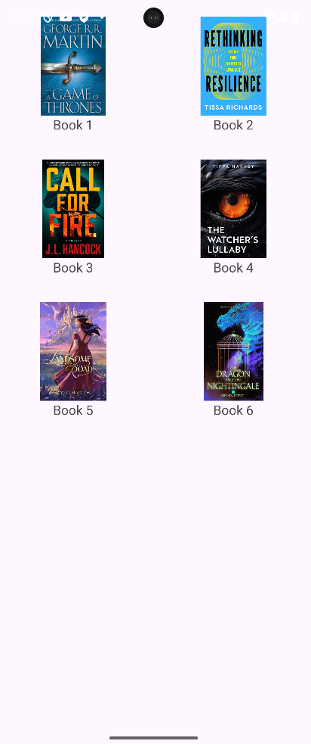
package com.techtitans.madpracticals;
import android.content.Context;
import android.view.LayoutInflater;
import android.view.View;
import android.view.ViewGroup;
import android.widget.BaseAdapter;
import android.widget.ImageView;
import android.widget.TextView;
public class GridAdapter extends BaseAdapter {
Context c;
int[] ids;
String[] b;
public GridAdapter(Context c, int[] ids, String[] b) {
this.c = c;
this.ids = ids;
this.b = b;
}
public int getCount() {
return ids.length;
}
public Object getItem(int p) {
return null;
}
public long getItemId(int p) {
return 0;
}
public View getView(int p, View v, ViewGroup g) {
if (v == null) {
v = LayoutInflater.from(c).inflate(R.layout.gridlayout, g, false);
}
ImageView img = v.findViewById(R.id.imageView);
TextView txt = v.findViewById(R.id.textView2);
img.setImageResource(ids[p]);
txt.setText(b[p]);
return v;
}
}

3.Wrap the entire layout in a ScrollView and test scrolling behavior.
2.Use ImageView to show a banner image for a hotel or library welcome screen.

MainActivity.java :

package com.techtitans.madpracticals;
import android.os.Bundle;
import androidx.appcompat.app.AppCompatActivity;
public class MainActivity extends AppCompatActivity {
@Override
protected void onCreate(Bundle savedInstanceState) {
super.onCreate(savedInstanceState);
setContentView(R.layout.activity_main);
}
}
activity_main.xml :
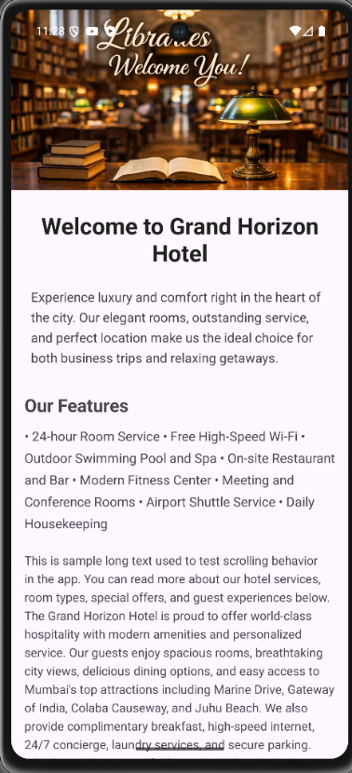
<?xml version="1.0" encoding="utf-8"?>
<ScrollView
xmlns:android="http://schemas.android.com/apk/res/android"
android:layout_width="match_parent"
android:layout_height="match_parent"
android:fillViewport="true"
android:scrollbars="vertical">
<LinearLayout
android:layout_width="match_parent"
android:layout_height="wrap_content"
android:orientation="vertical">
<ImageView
android:id="@+id/bannerImage"
android:layout_width="match_parent"
android:layout_height="220dp"
android:scaleType="centerCrop"
android:src="@drawable/img"
android:contentDescription="@string/welcome_banner"
android:importantForAccessibility="yes" />
<TextView
android:layout_width="match_parent"
android:layout_height="wrap_content"
android:padding="24dp"
android:textSize="28sp"
android:textStyle="bold"
android:textColor="#212121"
android:gravity="center"
android:text="@string/welcome_to_our_hotel" />
<TextView
android:layout_width="match_parent"
android:layout_height="wrap_content"
android:paddingHorizontal="24dp"
android:paddingBottom="16dp"
android:textSize="16sp"
android:lineSpacingExtra="6dp"
android:textColor="#424242"
android:text="@string/welcome_description_long" />
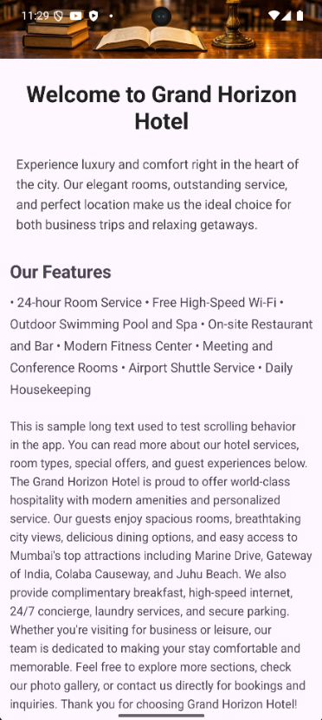
i
<LinearLayout
android:layout_width="match_parent"
android:layout_height="wrap_content"
android:orientation="vertical"
android:padding="16dp">
<TextView
android:layout_width="match_parent"
android:layout_height="wrap_content"
android:text="@string/our_features"
android:textSize="22sp"
android:textStyle="bold"
android:paddingBottom="12dp"/>
<TextView
android:layout_width="match_parent"
android:layout_height="wrap_content"
android:text="@string/features_list"
android:textSize="16sp"
android:lineSpacingExtra="8dp"
android:paddingBottom="24dp"/>
<TextView
android:layout_width="match_parent"
android:layout_height="wrap_content"
android:text="@string/lorem_ipsum_long"
android:textSize="15sp"
android:lineSpacingExtra="5dp"/>
</LinearLayout>
</LinearLayout>
</ScrollView>
Question 4 Create a ListView showing recent borrowers or hotel guests with names and check-in dates.
Question 6 Add click listeners to ListView items to show detailed information in a Toast.

MainActivity2.java :
package com.techtitans.madpracticals;
import android.os.Bundle;
import android.widget.AdapterView;
import android.widget.ArrayAdapter;
import android.widget.ListView;
import android.widget.Toast;
import androidx.appcompat.app.AppCompatActivity;
public class MainActivity2 extends AppCompatActivity {
String[] guests = {
"Guest 1\nCheck-in: 20/01/2016",
"Guest 2\nCheck-in: 21/01/2016",
"Guest 3\nCheck-in: 22/01/2016",
"Guest 4\nCheck-in: 23/01/2016",
"Guest 5\nCheck-in: 24/01/2016"
};
@Override
protected void onCreate(Bundle savedInstanceState) {
super.onCreate(savedInstanceState);
setContentView(R.layout.activity_main2);
ListView lst = findViewById(R.id.lsttview);
ArrayAdapter adp = new ArrayAdapter(
this,
R.layout.list_item,
R.id.textView,
guests
);
lst.setAdapter(adp);
lst.setOnItemClickListener(new AdapterView.OnItemClickListener() {
@Override
public void onItemClick(AdapterView<?> parent, android.view.View view, int position, long id) {
Toast.makeText(
MainActivity2.this,
guests[position],
Toast.LENGTH_SHORT
).show();
}
});
}
}

activity_main2.xml :
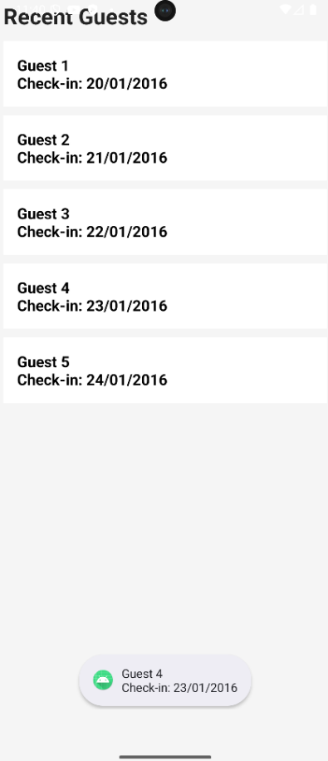
<?xml version="1.0" encoding="utf-8"?>
<LinearLayout xmlns:android="http://schemas.android.com/apk/res/android"
android:layout_width="match_parent"
android:layout_height="match_parent"
android:orientation="vertical"
android:background="#F5F5F5"
android:padding="16dp">
<TextView
android:layout_width="wrap_content"
android:layout_height="wrap_content"
android:text="Recent Guests"
android:textSize="26sp"
android:textStyle="bold"
android:textColor="#212121"
android:layout_marginBottom="12dp" />
<ListView
android:id="@+id/lsttview"
android:layout_width="match_parent"
android:layout_height="match_parent"
android:dividerHeight="10dp"
android:divider="@android:color/transparent" />
</LinearLayout>

List_item.xml :-
<?xml version="1.0" encoding="utf-8"?>
<LinearLayout xmlns:android="http://schemas.android.com
/apk/res/android"
android:layout_width="match_parent"
android:layout_height="wrap_content"
android:background="#FFFFFF"
android:padding="16dp"
android:orientation="vertical">
<TextView
android:id="@+id/textView"
android:layout_width="wrap_content"
android:layout_height="wrap_content"
android:textSize="18sp"
android:textStyle="bold"
android:textColor="#000000" />
</LinearLayout>

Q5. Implement a custom adapter to show book titles and images in GridView.
Q7. Combine GridView and ListView in a single screen to simulate a dashboard.

MainActivity.java :
package com.techtitans.madpracticals;
import android.os.Bundle;
import androidx.appcompat.app.AppCompatActivity;
import android.os.Bundle;
import android.widget.ArrayAdapter;
import android.widget.GridView;
import android.widget.ListView;
import androidx.appcompat.app.AppCompatActivity;
public class MainActivity extends AppCompatActivity {
int[] ids = {
R.drawable.img,
R.drawable.img_4,
R.drawable.img_6,
R.drawable.img_3
};
String[] books = {
"Book One",
"Book Two",
"Book Three",
"Book Four"
};
String[] guests = {
"Guest 1\nCheck-in: 20/01/2016",
"Guest 2\nCheck-in: 21/01/2016",
"Guest 3\nCheck-in: 22/01/2016",
"Guest 4\nCheck-in: 23/01/2016"
};
@Override
protected void onCreate(Bundle savedInstanceState) {
super.onCreate(savedInstanceState);
setContentView(R.layout.activity_main);
GridView grd = findViewById(R.id.grdView);
ListView lst = findViewById(R.id.lstview);
GridAdapter gadp = new GridAdapter(this, ids, books);
grd.setAdapter(gadp);
ArrayAdapter ladp = new ArrayAdapter(this, R.layout.list_item, R.id.textView, guests);
lst.setAdapter(ladp);
}
}

activity_main.xml
<?xml version="1.0" encoding="utf-8"?>
<ScrollView xmlns:android="http://schemas.android.com/apk/res/android"
android:layout_width="match_parent"
android:layout_height="match_parent"
android:fillViewport="true">
<LinearLayout
android:layout_width="match_parent"
android:layout_height="wrap_content"
android:orientation="vertical"
android:background="#F5F5F5"
android:padding="16dp">
<TextView
android:layout_width="wrap_content"
android:layout_height="wrap_content"
android:text="Library Dashboard"
android:textSize="26sp"
android:textStyle="bold"
android:textColor="#212121"
android:layout_marginBottom="12dp" />
<GridView
android:id="@+id/grdView"
android:layout_width="match_parent"
android:layout_height="wrap_content"
android:numColumns="2"
android:horizontalSpacing="12dp"
android:verticalSpacing="12dp"
android:stretchMode="columnWidth"
android:layout_marginBottom="20dp" />
<TextView
android:layout_width="wrap_content"
android:layout_height="wrap_content"
android:text="Recent Guests"
android:textSize="22sp"
android:textStyle="bold"
android:textColor="#212121"
android:layout_marginBottom="8dp" />
<ListView
android:id="@+id/lstview"
android:layout_width="match_parent"
android:layout_height="wrap_content"
android:divider="@android:color/transparent"
android:dividerHeight="10dp" />
</LinearLayout>
</ScrollView>

List_item.xml
<?xml version="1.0" encoding="utf-8"?>
<LinearLayout xmlns:android="http://schemas.android.com/apk/res/android"
android:layout_width="match_parent"
android:layout_height="wrap_content"
android:orientation="vertical"
android:background="#FFFFFF"
android:padding="16dp">
<TextView
android:id="@+id/textView"
android:layout_width="wrap_content"
android:layout_height="wrap_content"
android:textSize="18sp"
android:textStyle="bold"
android:textColor="#000000" />
</LinearLayout>

grid_item :-
<?xml version="1.0" encoding="utf-8"?>
<LinearLayout xmlns:android="http://schemas.android.com/apk/res/android"
android:layout_width="match_parent"
android:layout_height="wrap_content"
android:orientation="vertical"
android:background="#FFFFFF"
android:padding="16dp">
<TextView
android:id="@+id/textView"
android:layout_width="wrap_content"
android:layout_height="wrap_content"
android:textSize="18sp"
android:textStyle="bold"
android:textColor="#000000" />
</LinearLayout>

GridAdapter.java:-
package com.techtitans.madpracticals;
import android.content.Context;
import android.view.LayoutInflater;
import android.view.View;
import android.view.ViewGroup;
import android.widget.BaseAdapter;
import android.widget.ImageView;
import android.widget.TextView;
public class GridAdapter extends BaseAdapter {
Context c;
int[] ids;
String[] t;
public GridAdapter(Context c, int[] ids, String[] t) {
this.c = c;
this.ids = ids;
this.t = t;
}
public int getCount() {
return ids.length;
}
public Object getItem(int p) {
return null;
}
public long getItemId(int p) {
return 0;
}
public View getView(int p, View v, ViewGroup g) {
if (v == null) {
v = LayoutInflater.from(c).inflate(R.layout.grid_item, g, false);
}
ImageView img = v.findViewById(R.id.imageView);
TextView txt = v.findViewById(R.id.textView2);
img.setImageResource(ids[p]);
txt.setText(t[p]);
return v;
}
}
output :-

